# Background:

Data is recorded on student taking classes, course performance, absences and misbehavior. School administrator, teachers and parents are interested in various aspects (data subjects or perspectives) related to students. In this project we are interested in exploring the following data sets:

* 1. Student Academic Performance
  2. Student Absences
  3. Student Misbehavior & Discipline
  4. Special Needs Programs

The database used is Schools_K12_DW (backup attached to assignment) which is a Data Warehouse already in a dimensional model. It contains primary keys & foreign keys indicating data relationships.

There will also be a flat file for each table in the SQL Server database.

# Data Sources:

*Table 1: List of Data Source Table with Rows Counts*

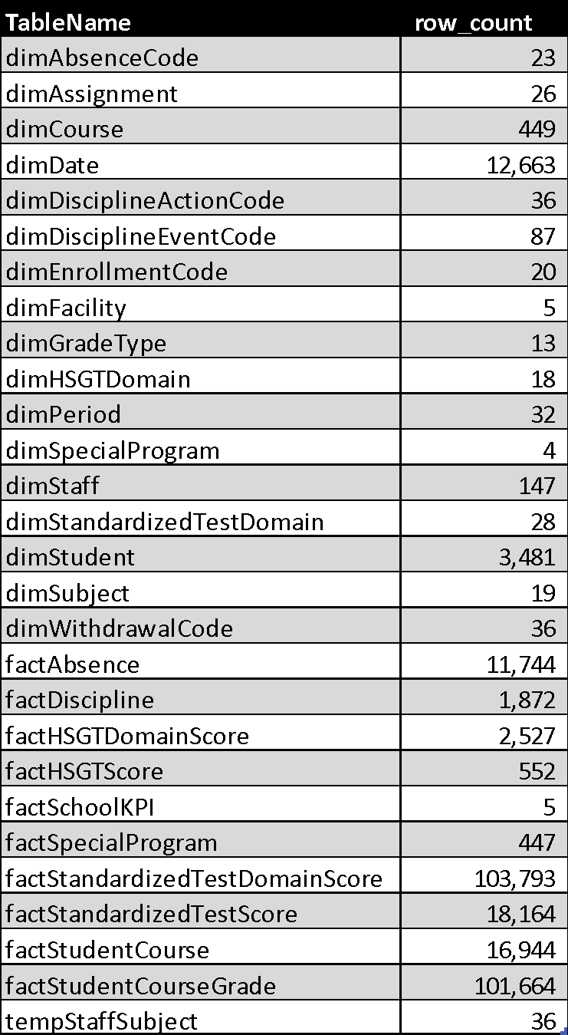

# Deliverables:

For this database perform the following tasks:

1. Create a dimensional data model for the following data subsets of Schools K12 DW:
   1. Absences
   2. Discipline Behavior
   3. Academic Performance
   4. Special Programs
2. Create a description & list sample types of analysis/queries for each data subset from the following perspectives:
   * School Administrator
   * Teacher
   * Parent
3. Create OLAP (SSAS) cube for each data model:
   1. Absences
   2. Discipline Behavior
   3. Academic Performance
   4. Special Programs
4. Write SQL queries for each of the sample queries above & present results
5. Use PowerBI using OLAP cubes & display results of above queries/analysis
6. Create two databases using the flat file, each a different DBMS, that recreates the Schools_K12_DW dimensional model & perform queries (#4) against each database. Select 2 of the following 3 dbms:
   * Oracle
   * MySQL
   * PostgreSQL

# Formats:

* Data Models (PDF)
* OLAP cubes (abf files)
* Written document
* SQL query results in Excel
* PowerBI dashboards (PDFs)
* Class Presentation & Demo